**Planning Meeting Minutes**

Date: November 28, 2023

Time: 7:00 PM - 9:00 PM

Location: Discord

**Attendees**

* 21127712 – Le Quang Truong Leader, Developer
* 21127443 – Tran Ngoc Truong Thinh Developer, Business Analyst
* 21127331– Nguyen Van Tuan Kiet Developer, Design
* 21127315 – Nguyen Gia Khanh Developer, Tester
* 21127606 – Bui Nguyen Hanh Developer, Tester

**Agenda**

* Project Status Update
* Create component diagrams
* Action Items and Next Steps

**Discussion**

Project planning

* Trường hosted the meeting, created documents and summarized the team's ideas.
* The team have partial filled out the Software Architecture document.
* Team made some draft about server components
* The team reviewed the project plan and discussed the improvement to cope with teacher’s comments

**Decisions**

1. Divide the work for writing use case descriptions
2. Tasks are assigned to each team member on Jira.
3. Each team member will complete the use case specifications as assigned.

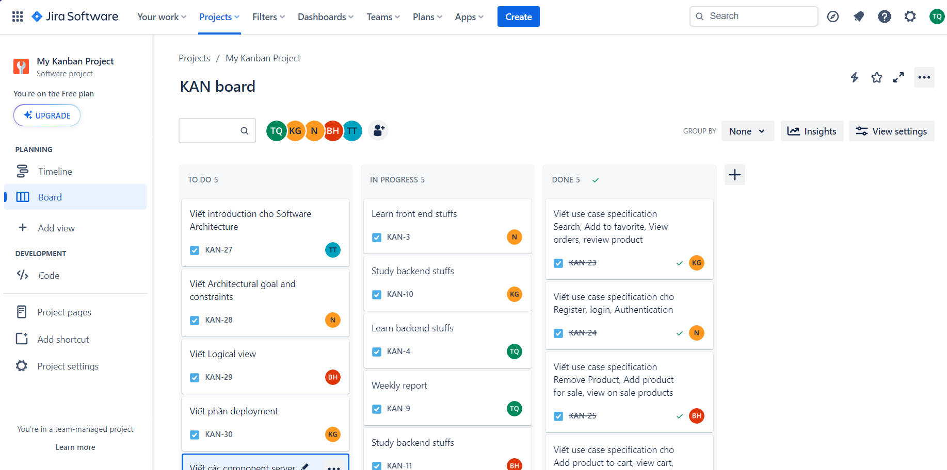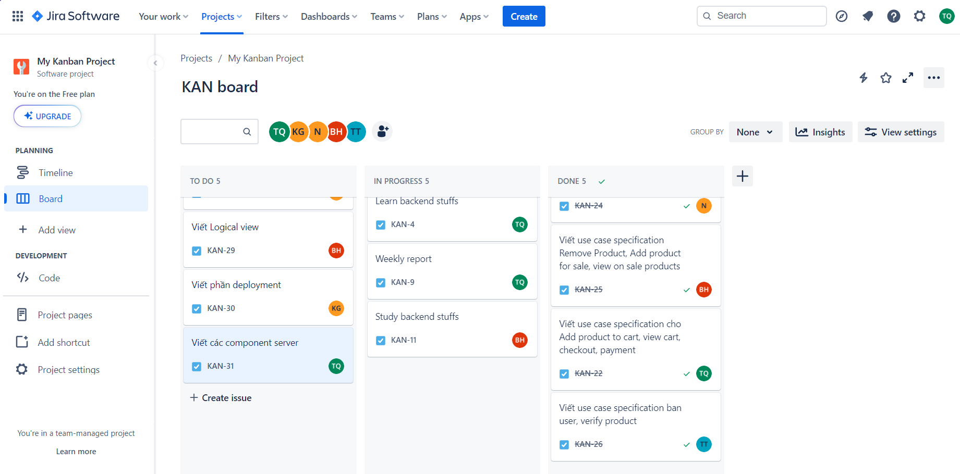

**Next Steps**

1. There will be 2 more meetings this week by 30/11, 2/12
2. Trường will announce the team when a change is needed.

**Adjournment**

The meeting concluded at 9:00 PM. The next meeting is scheduled for November 28, 2023, at 7:00 PM.

Prepared by:

Le Quang Truong(Team lead)